You really do not need to care about the file metadata.
The first two numbers are the hashes of the two files being compared.
The last number is an internal file mode identifier.
Usually this is two versions of the same file.
Git also declares one file as "A" and the other as "B"

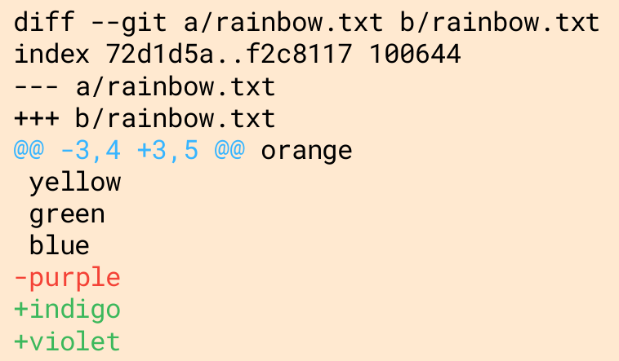
Changes Every line that changed between the two files is marked with either a + or symbol.
- lines that begin with - come from file A
- lines that begin with + come from file B
File A and File B are each assigned a symbol.
File A gets a minus sign (-) File B gets a plus sign (+)
Chunks:
A diff won't show the entire contents of a file, but instead only shows portions or "chunks" that were modified.
Chunks Header:
Each chunk starts with a chunk header.
found.@@ -3,4 +3,5 @@
- From file a, 4 lines are extracted starting from line 3.
- From file b, 5 lines are extracted starting from line 3.

